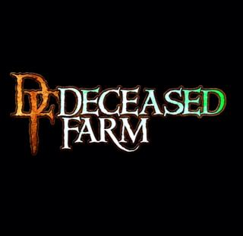
Deceased Farm 2021
Volunteer Release of Liability and Waiver of Claims for Use of Name, Photograph, Likeness, Video, or Sound Recording
I, _____________________ [Print Full Name], hereby consent to the use by Deceased Farm of my name, photograph, likeness, and film, video, or sound recording of me to promote or publicize Deceased Farm. I hereby release Deceased Farm, its members, and any sponsors from any and all liability for using my likeness/image and waive all claims arising from the use of any such images/recordings.
I also hereby grant a perpetual and irrevocable license to Deceased Farm to use any image in any manner, including, but not limited to, reproduction, sale, exhibition, copying, broadcast, and distribution of my image or information or any promotional situation Deceased Farm deems appropriate to promote its business. I understand that any recording of my image or likeness may be edited or combined with other images, sounds, text, or additional information. I expressly disclaim all rights to all values and benefits that may be gained through these images/likenesses.
I declare that I am over 18 years old or have my parent/guardian’s consent as indicated by their signature below. I have read this release, and I understand its contents.

Name: __________________________ Date of Birth:_________________ Gender:____________
Phone #:________________ E-Mail:________________________________________
Emergency Contact:________________________________ Relationship:___________ Phone:________
Volunteer Signature:________________________________________ Date:___________________
Parent/Guardian Signature (if under 18):________________________ Date:___________________

